**Creating a LoRaWAN Gateway**

There are many options you can pursue when choosing the hardware to use for LoRaWAN applications. You can choose to simply buy the pre-made TTN Gateway directly from TTN themselves, or you can choose a cheaper, more DIY route.

For our LoRaWAN Gateway we chose to build and configure our own. This quick how-to describes how our gateway was created, from choosing the correct parts to installing software.

**Choosing the Correct Hardware**

When building the gateway for yourself you need to make sure the hardware you choose is compatible. There are multiple options, but we will only focus on the option that we pursued.

We need the following hardware before we can get started:

* **Raspberry Pi**

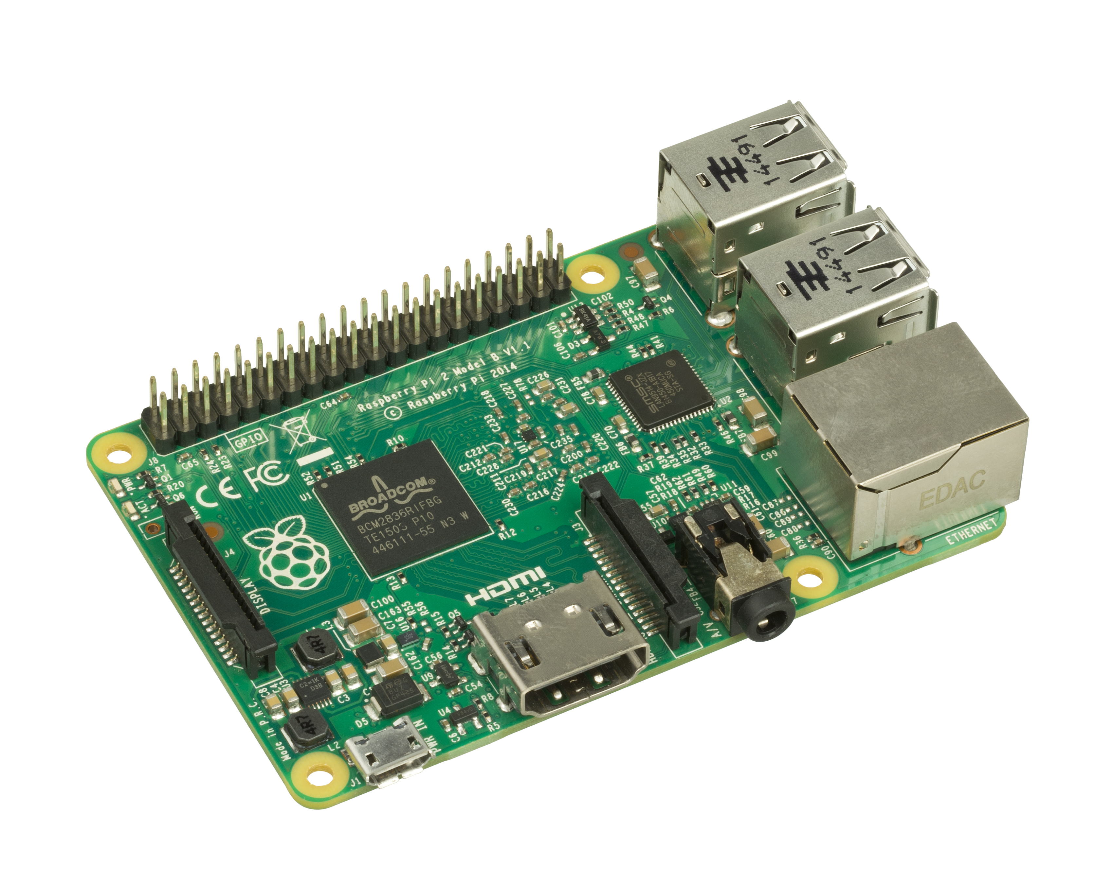

A Raspberry Pi is used as the main controller for the gateway. It will hold and run our software, and will be connected to the rest of our devices. Any Raspberry Pi model will do, but faster is generally better. We used a Raspberry Pi 1, Model B. This is one of the earlier models, but had enough speed to be able to keep up. We would recommend either a Raspberry Pi 2 or Raspberry Pi 3. Differences between the models can be found [here.](https://en.wikipedia.org/wiki/Raspberry_Pi#Specifications)

You can buy these boards from a variety of places around New Zealand, or you can import from overseas. I highly recommend [element14](http://nz.element14.com/raspberrypi-boards), As they are cheap and offer free delivery if your order is over $45.

* 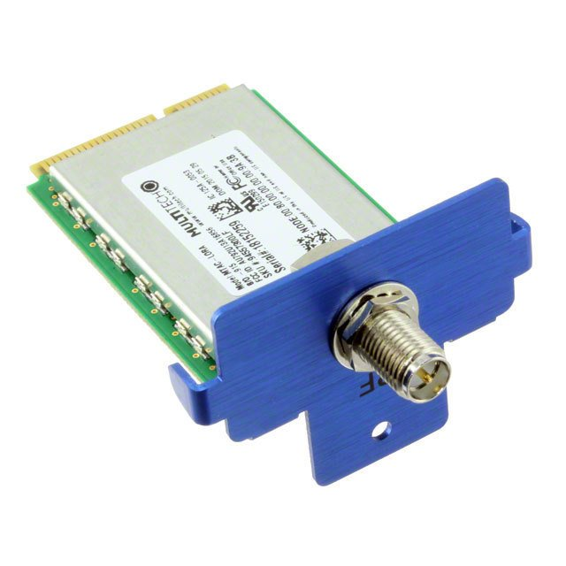**Multitech mCard-LoRa**

This is the sender and receiver of LoRaWAN packets, without this hardware the gateway will not be able to talk to our nodes. This device comes with an antenna, and is PCIe compatible.

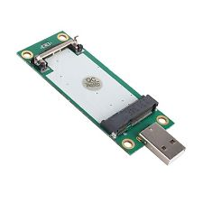

* **USB to Mini-PCIe Convertor**

This adaptor is necessary to connect the mCard to the Raspberry Pi, as the Pi does not have a Mini-PCIe slot itself.

**Installing and Running Software**

To be able to install the gateway software on the Raspberry Pi, the Pi itself needs to be set up. We used [Raspbian](https://www.raspberrypi.org/downloads/raspbian/), a version of Debian designed to run on a Raspberry Pi’s architecture. We won’t cover [how to install Raspbian](https://www.raspberrypi.org/documentation/installation/installing-images/README.md), as there is already a lot of documentation out there for it and it can be installed incredibly quickly and easily through NOOBS for Raspberry Pi.

Once you have a working version of Raspbian on your Raspberry Pi, you need to get the gateway software. There are multiple parts of software we need, so follow the next instructions carefully:

sudo apt-get update

sudo apt-get install git --assume-yes

sudo apt-get install libftdi-dev --assume-yes

cd ~

wget http://libmpsse.googlecode.com/files/libmpsse-1.3.tar.gz

tar zxvf libmpsse-1.3.tar.gz

cd libmpsse-1.3/src

./configure --prefix=/usr --disable-python

make

sudo make install

cd /etc/udev/rules.d

sudo wget https://raw.githubusercontent.com/mirakonta/lora_gateway/master/libloragw/99-libftdi.rules

sudo udevadm control --reload-rules

sudo udevadm trigger

sudo adduser pi plugdev

cd ~

Now we have our dependencies we can download and compile the LoRaWAN Gateway Software:

mkdir ~/lora

cd ~/lora

mkdir exec

git clone https://github.com/mirakonta/lora_gateway.git

git clone https://github.com/mirakonta/packet_forwarder.git

cd ~/lora/lora_gateway

make clean all

cd ~/lora/packet_forwarder

make clean all

cp ~/lora/packet_forwarder/basic_pkt_fwd/basic_pkt_fwd ~/lora/exec/

cp ~/lora/packet_forwarder/basic_pkt_fwd/*.json ~/lora/exec/

cd ~/lora/exec

The gateway code is now compiled and ready to go. To run the gateway, simply run the command:

sudo ./basic_pkt_fwd

**Running the Gateway Automatically (Headless)**

After installing and configuring the gateway using the above steps, you may find it desirable to have the gateway software run automatically, rather than logging in to the Pi and starting it manually.

To do this, we would use [Cron](https://en.wikipedia.org/wiki/Cron). Cron is a job scheduler which is built-in to many versions of Linux. Do the following to start the LoRa gateway software at boot:

After logging in to the Pi, type: “sudo crontab -e”

Use the down arrow to move to the end of the file.

Type “@reboot ./[location of basic_pkt_fwd]”.

Save the file.

“@reboot” tells Cron to run the job at boot.

Restart the gateway. If the software runs at startup, you have successfully set everything up. If not, you may need to check the crontab file or recheck the directory the file is in for any mistakes.

**Troubleshooting Hardware (optional)**

Something you may need to do is a small hardware modification on the Mini-PCIe adaptor to provide more power to the antennae. We didn’t end up having to do it, as our board worked anyway. However, if you have completely set up the gateway and it still doesn’t seem to be working, you can try this optional step.

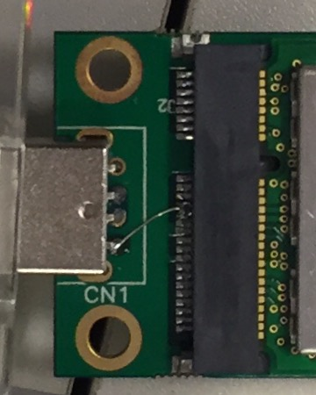Sometimes it may be necessary to provide extra power to a couple of the pins on the adaptor. To do this we need to solder a wire from the 5V pin on the USB connector to pins 23 and 25 of the PCIe connector. Below is a picture of the completed modification: